MFC DLLs Tutorial

The objective of this tutorial is to demonstrate in a step by step manner how to build and call methods present in a DLL using Visual Studio 2008
Extension DLL

The Tutorial explains how to create an extension dll and use it a VC++ client application.
Creating an MFC Extension Dll

- Create Skeleton of the Dll Use MFC AppWizard to create an extension dll's skeleton. Fig-1

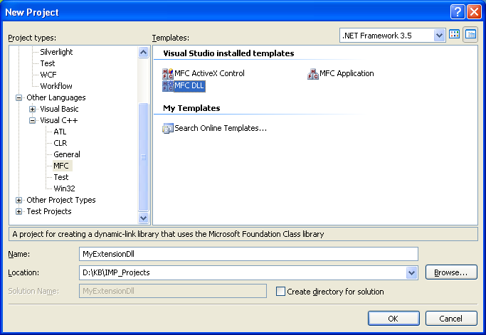
Fig-1

2.Select MFC Extension Dll Fig-2

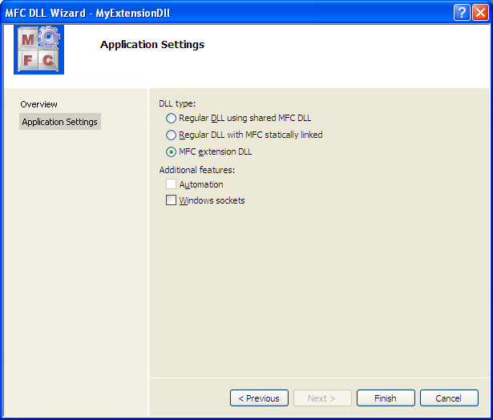
Fig-2
3.Add a new class Right click on MyExtensionDllClasses in Class View and Click
Add->Class.
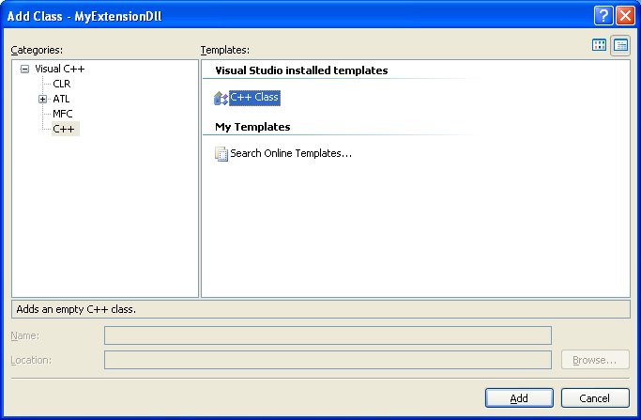

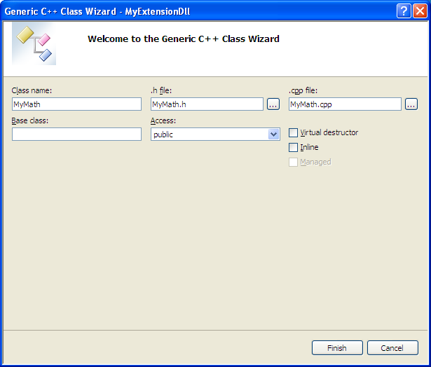

4.Add new New Functions by Right click on MyMath in Class View and Click
Add->Add Function.

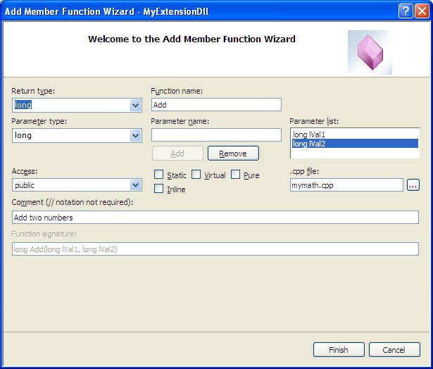

5. Wizard adds code to these functions. Add returns sum of two values and Multiply returns multiplied value of two numbers.

class AFX_EXT_CLASS CMyMath
{
public:
CMyMath(void);
~CMyMath(void);
// Add two values
long Add(long lVal1, long lVal2);
// Subtract two values
long Sub(long lVal1, long lVal2);
// Multiply two values
long Mul(long lVal1, long lVal2);
};

6. Build the Project and Copy the Dll to the client exe location

A DLL Test Client MyExtensionDll_Client Program

1. Create a dialog based application. Your dialog template should look like Fig-1
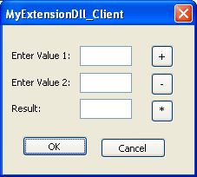
Fig-1

2. Copy MyMath.h (your extension class's header file) class to your project directory.

2. Link Library Fig – 2
Project->Properties->Linker->Input->Additional Dependencies
1.Add the Dll .Lib
2.Put the Dll in the Client Exe Directory
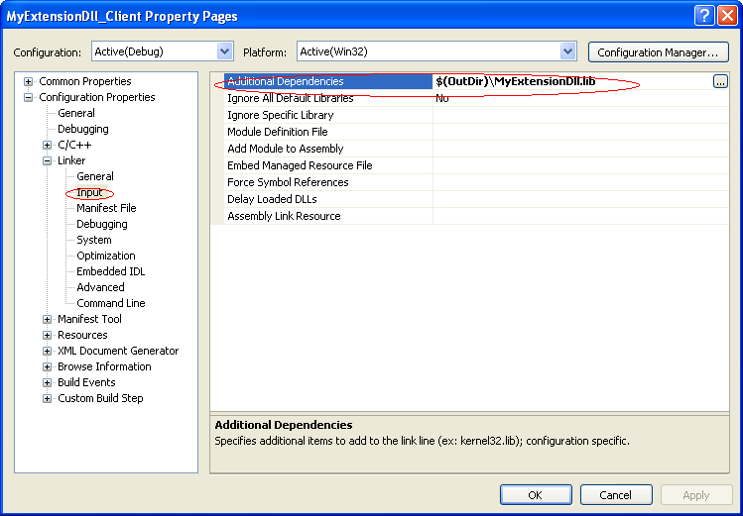
Fig – 2

4. Include header file. Include ‘MyMath.h' in your project's stdafx.h file.

5. Create Object of the class. Add these public members to your dialog's header class.

class CMyExtensionDll_ClientDlg : public CDialog
{
public:
CMyMath m_objMath;
long m_lVal1;
long m_lVal2;
long m_lResult;

6. Use the class. Now we are ready to use Add and Multiply member functions of extension dll's McCalculator class. Override OnClick of Add and Sub buttons and write this code:

void CMyExtensionDll_ClientDlg::OnBnClickedButAdd()
{
m_lVal1 = GetDlgItemInt( IDC_EDIT_VALUE_1);
m_lVal2 = GetDlgItemInt( IDC_EDIT_VALUE_2);
m_lResult = m_objMath.Add(m_lVal1, m_lVal2);
SetDlgItemInt( IDC_EDIT_RESULT, m_lResult, TRUE );
}

void CMyExtensionDll_ClientDlg::OnBnClickedButSub()
{
m_lVal1 = GetDlgItemInt( IDC_EDIT_VALUE_1);
m_lVal2 = GetDlgItemInt( IDC_EDIT_VALUE_2);
m_lResult = m_objMath.Sub(m_lVal1, m_lVal2);
SetDlgItemInt( IDC_EDIT_RESULT, m_lResult, TRUE );
}

7. Build and Run your project. Enter two numbers in edit box 1 and 2 and click Add or Multiply

Regular DLL
Ref:
http://www.codeproject.com/KB/DLL/RegDLL.aspx

Creating an MFC Regular Dll

The Tutorial explains how to create a regular MFC dll and use it in a client application.

- Create Skeleton of the Dll Use MFC AppWizard to create a dll's skeleton.

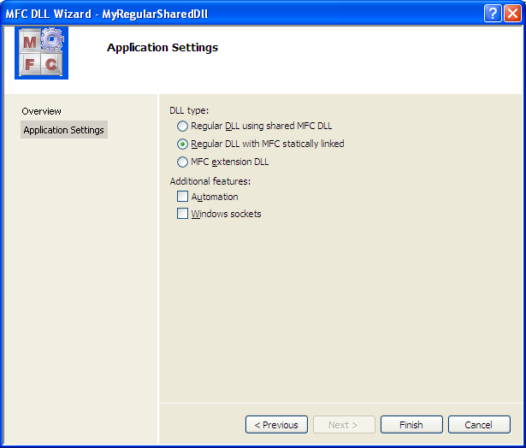

2.Adding Functions to the DLL MyRegularSharedDllApp.cpp

Example:
extern "C" __declspec(dllexport) returnValue MyFunction( parameters)
{
AFX_MANAGE_STATE(AfxGetStaticModuleState());
// normal function body here
}

extern "C" __declspec(dllexport) long Add(long lVal1, long lVal2)
{
AFX_MANAGE_STATE(AfxGetStaticModuleState());

return (lVal1 + lVal2);
}

extern "C" __declspec(dllexport) long Sub(long lVal1, long lVal2)
{
AFX_MANAGE_STATE(AfxGetStaticModuleState());

return (lVal1 - lVal2);
}

Build the Project and Copy the Dll

Now compile and build the project and copy from your Debug directory to the Client EXE directory.

A DLL Test Client Program – Implicit linking

1. Link Library
Project->Properties->Linker->Input->Additional Dependencies
1.Add the Dll .Lib
2.Put the Dll in the Client Exe Directory

2. Import functions. Import functions using __declspec. Write this code in the beginning of your cpp file.

extern "C" __declspec(dllimport) long Add( long val1, long val2);
extern "C" __declspec(dllimport) long Sub( long val1, long val2);
extern "C" __declspec(dllimport) long Mul( long val1, long val2);

void CMyRegularSharedDll_ClientDlg::OnBnClickedButAdd()
{
m_lVal1 = GetDlgItemInt( IDC_EDIT_VALUE_1);
m_lVal2 = GetDlgItemInt( IDC_EDIT_VALUE_2);
m_lResult = Add(m_lVal1, m_lVal2);
SetDlgItemInt( IDC_EDIT_RESULT, m_lResult, TRUE );
}

void CMyRegularSharedDll_ClientDlg::OnBnClickedButSub()
{
m_lVal1 = GetDlgItemInt( IDC_EDIT_VALUE_1);
m_lVal2 = GetDlgItemInt( IDC_EDIT_VALUE_2);
m_lResult = Sub(m_lVal1, m_lVal2);
SetDlgItemInt( IDC_EDIT_RESULT, m_lResult, TRUE );
}

3. Call Functions.

long lSum = Add(m_lVal1, m_lVal2);
long lSub = Sub(m_lVal1, m_lVal2);

A DLL Test Client Program – Explicit linking

typedef long (*CALCFUN)(long, long);

void CMyRegularSharedDll_Client_ExplicitLinkingDlg::OnBnClickedButAdd()
{
m_lVal1 = GetDlgItemInt( IDC_EDIT_VALUE_1);
m_lVal2 = GetDlgItemInt( IDC_EDIT_VALUE_2);

m_lResult = GetResult("Add", m_lVal1, m_lVal2);
SetDlgItemInt( IDC_EDIT_RESULT, m_lResult, TRUE );

}

void CMyRegularSharedDll_Client_ExplicitLinkingDlg::OnBnClickedButSub()
{
m_lVal1 = GetDlgItemInt( IDC_EDIT_VALUE_1);
m_lVal2 = GetDlgItemInt( IDC_EDIT_VALUE_2);

m_lResult = GetResult(("Sub"), m_lVal1, m_lVal2);
SetDlgItemInt( IDC_EDIT_RESULT, m_lResult, TRUE );
}

long CMyRegularSharedDll_Client_ExplicitLinkingDlg::GetResult
(const char* strOperation, long lVal1, long lVal2)
{
CALCFUN pFun;
HMODULE hMod; // handle to loaded library module
BOOL bRes; // BOOL to check if DLL was successfully unloaded

// returns a handle to the DLL, otherwise NULL
hMod = LoadLibrary(_T("MyRegularSharedDll.dll"));

// returns the address of the DLL functions, otherwise NULL
//const char* op = strOperation;
pFun = (CALCFUN) GetProcAddress(hMod, strOperation);

// (DLL function address) (function parameters)
long lResult = (pFun)(lVal1, lVal2);

// returns nonzero if sucussful
bRes = FreeLibrary(hMod);

return lResult;
}

